SMART PUBLIC RESTROOM

SUBMITTED BY:

NAME: KUMMARI SAI TEJA

REG NO:723921106004

E-MAIL:kummarisai teja22446688@gmail.com

smart public restroom involves several key objectives, device setup, platform development, code implementation, and data sharing platform considerations. Here's a high-level overview of each aspect:

1. Objectives:

a. **Enhanced User Experience:** The primary objective of a smart public restroom is to improve the overall user experience. This includes providing cleanliness, accessibility, and convenience.

b. **Resource Efficiency:** Smart restrooms should aim to reduce resource wastage, such as water and energy, by implementing automated systems.

c. **Health and Safety:** Ensure that the restroom is a safe and hygienic environment for users, especially in the post-pandemic era. Implement touchless technologies and cleanliness monitoring.

d. **Sustainability:** Minimize the environmental impact by using eco-friendly materials, energy-efficient devices, and water-saving fixtures.

1. Device Setup:

a. **Sensor Integration:** Install sensors for occupancy detection, water flow, soap dispensing, and waste management.

b. **IoT Devices:** Use IoT devices to monitor restroom conditions, such as air quality, temperature, and humidity.

c. **Security Cameras:** Install cameras for security and monitoring purposes. Ensure compliance with privacy regulations.

d. **Smart Fixtures:** Use touchless fixtures, like automatic faucets, soap dispensers, and flush systems.

1. Platform Development:

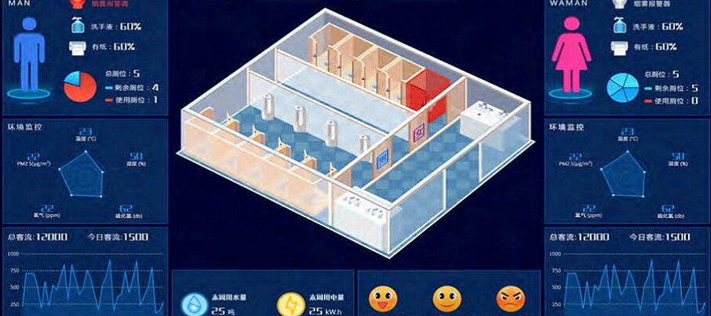

a. **Data Aggregation:** Create a platform for aggregating data from all installed devices and sensors in real-time. This platform could be cloud-based or on-site.

b. **User Interface:** Develop user-friendly interfaces for both restroom users and administrators. Users can access information on restroom availability and conditions, while administrators can monitor and manage the restroom remotely.

c. **Analytics and Insights:** Implement analytics to gain insights into restroom usage, resource consumption, and maintenance needs. Use machine learning algorithms to predict and optimize restroom operations.

d. **Notifications:** Develop a notification system to alert maintenance staff when cleaning or restocking is required.

1. Code Implementation:

a. **Programming Sensors:** Write code to interface with sensors, collect data, and transmit it to the platform.

b. **Automation Logic:** Implement logic to automate restroom functions, such as turning off lights when not in use, controlling water flow, and regulating air quality.

c. **Security Protocols:** Ensure the security of data and access control through robust encryption and authentication mechanisms.

d. **Error Handling and Redundancy:** Develop code to handle errors and ensure system redundancy in case of failures.

1. Data Sharing Platform:

a. **Data Privacy and Compliance:** Ensure that the platform complies with data privacy regulations, like GDPR or HIPAA, if applicable. Users' data should be protected.

b. **APIs and Integration:** Provide APIs for third-party integration, allowing other systems (e.g., local municipalities, mapping apps) to access restroom data.

c. **Scalability:** Design the platform to be scalable, allowing for easy expansion to multiple restrooms within a city or region.

d. **User Feedback:** Incorporate user feedback mechanisms to continuously improve the restroom experience based on real-time data.

Remember that the specific technology and platform you choose may vary depending on the scale and requirements of the project. Collaborate with experts in IoT, software development, and facility management to ensure a successful implementation of a smart public restroom.

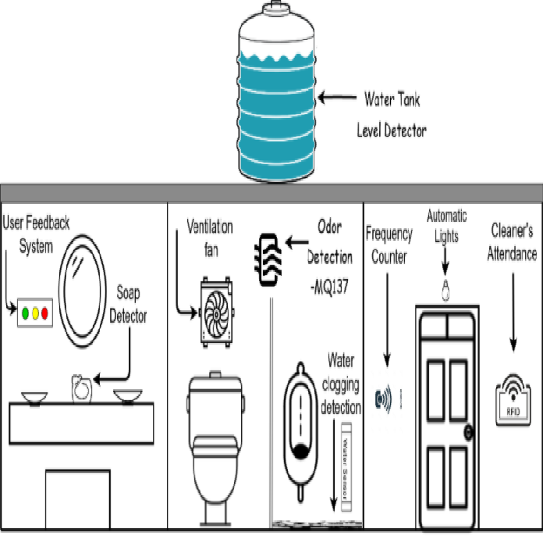

Developing the code for a smart public restroom involves creating the software that interacts with sensors, controls devices, and manages the overall operation of the restroom. Below is a simplified outline of code development for a smart public restroom system. Keep in mind that this is a high-level overview, and the specifics will depend on the technology stack and hardware components you use.

1. **Sensor Integration**:
   * Write code to interface with various sensors, such as occupancy sensors, temperature sensors, humidity sensors, and air quality sensors.
   * Use appropriate libraries or APIs provided by sensor manufacturers to collect data.
   * Implement error handling and data validation to ensure data accuracy.
2. **IoT Device Integration**:
   * Develop code to communicate with IoT devices controlling fixtures like automatic faucets, soap dispensers, flush systems, and hand dryers.
   * Implement logic for remote device management and control.
   * Ensure that the code can handle various communication protocols (e.g., MQTT, HTTP, CoAP) depending on the IoT devices.
3. **User Interface**:
   * Create a user-friendly interface for restroom users. This could be a mobile app or a web portal.
   * Implement features such as real-time restroom availability information, QR code scanning for touchless access, and user feedback submission.
   * Write code to display restroom conditions and alerts to users.
4. **Administrative Interface**:
   * Develop a separate administrative interface for monitoring and managing the smart restroom.
   * Implement authentication and access control to ensure only authorized personnel can access the admin portal.
   * Include features for remotely controlling fixtures, reviewing analytics, and receiving maintenance alerts.
5. **Analytics and Insights**:
   * Write code to collect and process data from various sensors and devices.
   * Implement analytics algorithms to generate insights on restroom usage patterns, resource consumption, and maintenance needs.
   * Use machine learning or statistical models for predictive maintenance and resource optimization.
6. **Notifications and Alerts**:
   * Develop code to send notifications to maintenance staff and administrators when cleaning, restocking, or maintenance is required.
   * Use push notifications, email, or SMS to deliver alerts in real-time

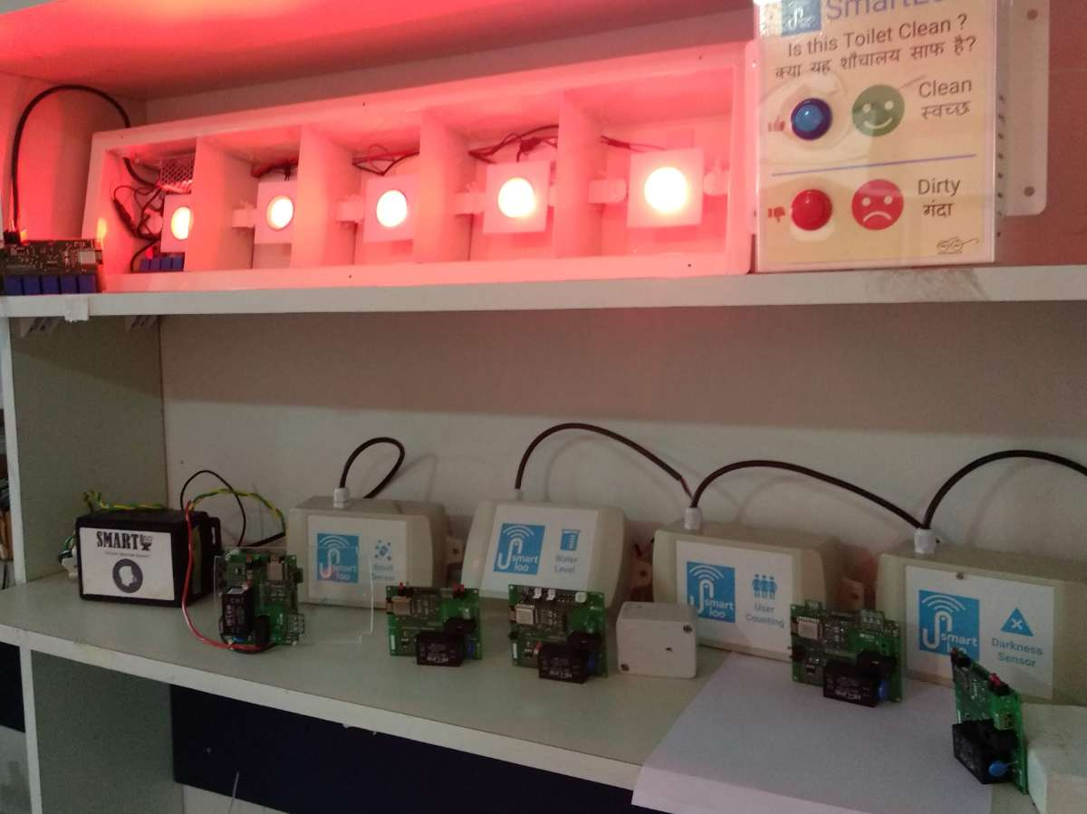**7.Security**:

* + Implement robust security measures to protect data and access.
  + Use encryption to secure data transmission.
  + Implement user authentication and authorization.
  + Regularly update and patch the code to address security vulnerabilities.

1. **Error Handling and Redundancy**:
   * Write code to handle errors gracefully and recover from failures.
   * Implement redundancy and failover mechanisms to ensure uninterrupted restroom operation.
2. **Integration with Data Sharing Platform**:
   * Develop code for integrating with a data sharing platform, whether it's cloud-based or on-site.
   * Ensure proper data synchronization and data sharing protocols.
3. **Scalability and Maintainability**:
   * Design the code with scalability in mind, allowing for easy integration with additional restrooms and devices.
   * Use coding best practices and documentation for maintainability.
4. **Testing and Quality Assurance**:
   * Thoroughly test the code for functionality, performance, and security.
   * Conduct user acceptance testing to ensure the user interface meets user needs.
5. **Deployment**:
   * Deploy the code to the restroom's hardware infrastructure.
   * Continuously monitor and maintain the code to address issues and make improvements.

This code development process will require collaboration between software developers, IoT experts, and domain experts in restroom management to ensure the smart public restroom functions efficiently and provides a superior user experience.

Top of Form

Top of Form